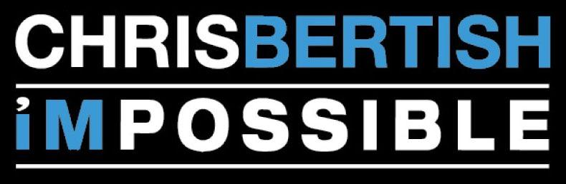

Chris Bertish- Biography 2022
Chris Bertish is a professional speaker, big wave surfing Mavericks champion, stand up paddle board Guinness World Record holder, best-selling author, award-winning film director, philanthropist, conservationist, ocean pioneer and entrepreneur.
He was recently recognized as one of the Top 5 Speakers in South Africa and selected as one of the Genius 100-Global Visionaries for the future, by the Einstein Institute, both for excellence in his disciplines and universal global positive influence. Together, Chris and his fellow visionaries, Deepak Chopra, Sir Ken Robinson, Ruth Bader Ginsberg and Shimon Peres are collaborating with the intent to inspire the next generation of geniuses.
His incredible Mavericks big wave story was developed into a globally inspiring and award-winning film, Ocean Driven, and then emerged into the best-selling book-Stoked! In 2017, Red Bull Adventure exclaimed Chris “redefined the concept of extreme adventure” when he became the first person ever to stand up paddle across any ocean. Defying all odds, he navigated 4660 mi (7500 km) solo, unsupported and unassisted for 93 days, across the Atlantic Ocean from Morocco, Africa to the Caribbean Island of Antigua. The Sup Crossing was a truly unparalleled global feat, while raising money and awareness for conservation and to help disadvantaged children in Africa, through the Lunchbox Fund and Operation Smile.
He has become renowned for his dynamic and inspiring keynote addresses delivered around the globe, which move audiences to tears and laughter, with a powerful narrative and audio-visual overload that keeps people on the edge of their seats from start to finish.
Chris Bertish shifts boundaries and shatters perceptions of what’s possible, while using his voice, his stories and his adventures as a force for good and positive change. He is B Corp, Climate Neutral business, using his adventures and projects to support charities, both in the humanitarian, educational, sustainability and environmental realms, to bring about tangible positive change, inspiring us to give back, be better humans, become more purpose driven and discover our greatest potential.
Chris is an Ambassador for Sea Trees, Operation Smile, Tide.Earth and recently been taken on as a global Ambassador for Conservation International and through his business he annually plants multiple forests around the world, to be an example to others of the change we wish to see in the world.

Chris and his team have just finished and launched his new feature film documentary called “Last known Co-ordinates” globally, on his mind-altering, purpose driven, solo, unsupported, Trans-Atlantic Sup Crossing journey.
In May/ June / July 2022 Chris will be Wing Foiling, solo and unsupported, across the Pacific Ocean, from California to Hawaii, over 2500 Nautical Miles. A project powered by nature, for nature. All tied into the UN’s 17 global SDG’s and doing this all to create awareness on Climate Change and the action we all need to take now, to minimize the negative impact and help us make a positive difference and get down to carbon net zero by 2030.
Over 2022, Chris will be finishing up on his second Book “All in!” on his incredible Atlantic journey, which will launch globally in August/ September of this year.
Chris will be doing a USA Roadshow late 2022/ 2023, across America, launching his new book and Speaking across the USA, while trailering his little craft across the entire country, highlighting the Climate Change, doing this roadshow, all completely powered by Nature for Nature.
Everything Chris does is about leading by example and being the change we want to see in the world, each and every day.

